The Immune System

Pathogens can enter your body in a number of ways.
Method of Entry | Examples of Diseases

First Line of Defence
The first line of defence is to prevent the pathogens from entering the body.
Skin is an effective barrier. ____________________________________________________
__________________________________________________________________________
Fluids such as tears and saliva have antiseptic properties. ____________________________
___________________________________________________________________________
Air entering the nose is filtered by hairs in the nostrils. ______________________________
___________________________________________________________________________
Pathogens entering the digestive system are usually killed by stomach acid. _____________
___________________________________________________________________________

Second Line of Defence
Once a pathogen enters the ____________________________________________________
___________________________________________________________________________
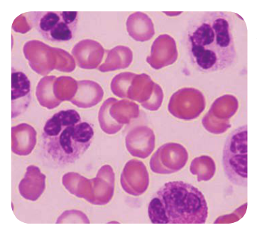
This is called __________________________.
Damaged cells __________________________________
______________________________________________
In the blood ____________________________________
______________________________________________
Dead neutrophils _______________________________________

Third Line of Defence
The lymphatic system _________________________________________________________
___________________________________________________________________________
In areas of the lymphatic system there are swellings called ___________________________
Lymph nodes contain large numbers of ___________________________________________
___________________________________________________________________________
Macrophages are similar to neutrophils. __________________________________________
Lymphocytes make chemicals called ___________________
Antibodies cause pathogens to _________________________________________________
__________________________________________________________________________

Antibodies
Each pathogen ______________________________________________________________
The first time the lymphocytes _________________________________________________
__________________________________________________________________________
The next time your immune system ______________________________________________
__________________________________________________________________________
You are now immune to the pathogen.

Temperature
To help fight infection,_________________________________________________________
Pathogens that enter the body __________________________________________________
When your body temperature is higher, __________________________________________
___________________________________________________________________________


